**Layout with Flex**

We've already looked at **display:inline-block** and **vertical-align:top** to change our layouts, but there is another more modern method known as **Flexbox.** Unlike inline-block, flex is a system that works by defining parent elements as **flex containers.**These flex containers turn all their children into **flex items.**

Let's look at a header that has two items in it:

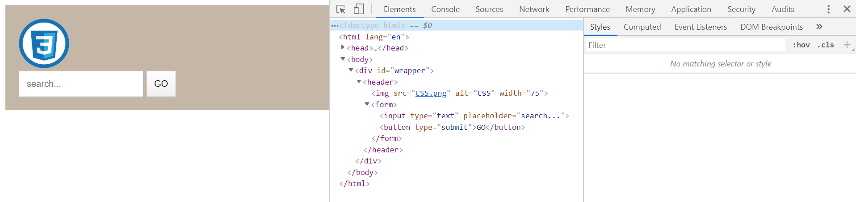

There is a logo and a search bar. Say we want the search bar to be at the opposite end if the header. Flex makes this easy! Let's target the header in CSS and change it to a flex container:

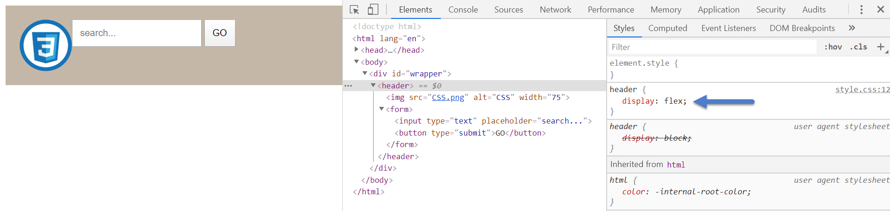

Now header's two children, img and form, are next to each other. Because header is a flex container now, we can use other flex features to create the layout we want. One of them is **justify-content:space-between.**

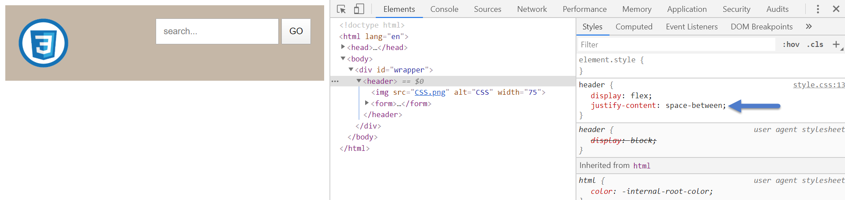

No matter how big our browser is, our items will now be perfectly separated. Nice! What if we wanted to center them vertically? We can use **align-items:center.**

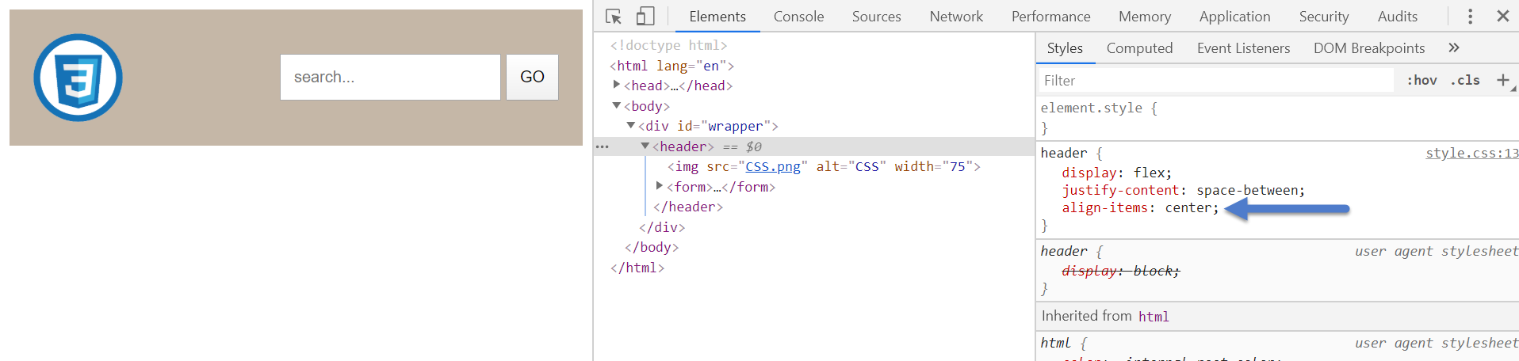

Try playing with the different values for **justify-content**and **align-items.**

Another great flex property is **flex-wrap:wrap;**. Setting this on your flex container will automatically adjust your flex items to a single column when the browser is too small. Mobile-friendly!